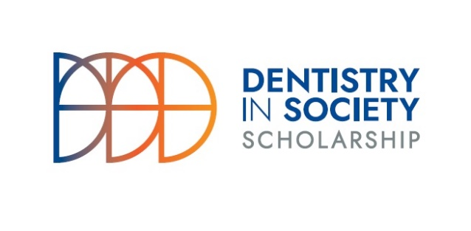
ADEE GSK Scholarship

Dentistry in Society Award
(Supported by GSK)

Section One: the Applicant

Applicant Name
(Lead person on project)
ADEE Membership Institution
Contact Address
Telephone
Email
Declaration | By signing this application form I hereby acknowledge the following:  I understand that application for the ADEE bursary is no guarantee of funding  I have authorisation to apply on behalf of the Institution  If successful I commit to writing a report on how the funding was utilised to the benefit of dental education which may be published by ADEE  If successful I commit to presenting on project at an ADEE annual meeting or on an online format within 2 years of the award  I will acknowledge ADEE as providing the institution with the bursary  I agree that the decision of the committee is final and binding and not subject to appeal
Signature
Date

SECTION TWO: About the organisation’s approach to enabling and advancing dental education
Briefly summarise the aims and objectives of the strategy used by the institution to advance teaching and learning practice within the dentistry in society domain
(300 words)
Detail achievements of this strategy within the past 5 years, numbers processed, changes made etc.
(300 words)

Section Three: Supporting Narratives
Provide a rationale as to why your feel this application should be supported and how the scholarship will support the advancement of the dentistry in society domain within your Institution and further afield
(300 words)
Please detail how your institution has supported ADEE activities in the past
(250 words)
Please detail the specific items funding awarded will be/has been spent on and their associated costs
(250 words, you may submit a more detailed spreadsheet if you wish)
Please detail how you can demonstrate and validate the effectiveness of the approach taken with regards to teaching and learning practices of the dentistry in society domain.
(200 words)
Please detail any further information you think appropriate to support your application
(200 words)

Section Four: Checklist
Please ensure the following have been emailed to scholarship@adee.org
Item
Fully completed application form
Signed declaration by dean on School
Letter of application from the Dean’s office signed and on headed paper
Any support material you deem appropriate

Section Five: Time Frames

Date | Details
May | Call for applications issued by ADEE
31st August at 17:00 Irish time | Closing date for applications
15th September (provisional) | First round evaluations complete and calls for additional information if required issued to applicants
Late September (provisional) | Final evaluations completed and recommendations report to award bursary issued to Executive Committee for approval
Date to be confirmed | Announcement of awards and online webinar

